CIS 452

Lab 2 Report

Ashley Hendrickson

Muna Gigowski

Fall 2019

Table of Contents

online help 2

Question One 2

Question Two 2

include files 2

Question Three 2

Useful UNIX Fundamentals 2

Question Four 2

Question FIve 2

Program Debugging 2

Question Six 2

Dynamic Memory Debugging 2

Question Seven 2

System profiling 2

Question Eight 2

Question Nine 2

Programming assignment 2

Source Code 2

Variances 2

References 2

# Process Creation

## Question One

**How many lines are printed by the program?**

3 lines:

Before fork

After fork

After fork

## Question Two

**Describe what is happening to produce the answer observed for the above question.**

When the program executes, it prints the first line, “Before fork,” before fork() is called. Then, once fork() is called the parent program is still running, so it prints the next line after the call to fork(), which is the line that says “After fork.” At the same time that the parent is printing its “After fork” line though, the duplicate child process that was created is also running and prints its “After fork” line as well.

## Question Three

**Consult the man pages for the ps (process status) utility; they will help you determine how to display and interpret the various types of information that is reported.  Look especially for "verbose mode" or "long format". Then, using the *appropriate* options, observe and report the PIDs and the status (i.e. state info) of your executing program.  Provide a brief explanation of your observations.**

Using command “ps -l” :

F S   UID PID  PPID C PRI  NI ADDR SZ WCHAN  TTY TIME CMD

0 S  8772 18490 13463  0 80 0 -  1431 -  pts/2 00:00:00 bash

0 S  8772 32028 18490  0 80 0 -   572 -  pts/2 00:00:00 a.out

1 S  8772 32029 32028  0 80 0 -   572 -  pts/2 00:00:00 a.out

4 R  8772 32054 18490  0 80 0 -  2411 -  pts/2 00:00:00 ps

The results above can be explained fairly simply, one process at a time:

Bash - This process was the first running, since it is the command interpreter we are using to execute all of our other commands. It’s process ID is shown, and it’s state is shown as an “S” because bash is waiting for the other programs we are running to finish execution, so it can resume.

A.out (top one) - This is our parent process, which we can tell by looking at its process ID (32028), which is one lower than the other a.out (meaning that process is the child process because it was created after this one). Upon us executing the ps -l command, this process has a status of “S,” which makes sense because we told it to sleep for ten seconds inside the program’s code after fork() call.

A.out (bottom one) - This is our child process, which we determined above based on looking at its process ID. The state of this process is also “S” because we added the sleep(10) line after the fork() call in the code, meaning that after the child was created with fork() it picked up execution right at the sleep(10) line - also causing it to sleep for 10 seconds along with its parent process.

Ps - This is our ps -l command, and its status is “R” because it was the only process currently running at the time the results were printed out (and understandably so, because it was the process that was doing the printing out of the results).

## Question Four

**Create a diagram illustrating how Sample Program 2 executes. I.e. give a process hierarchy diagram (as described in class and in your textbook).**

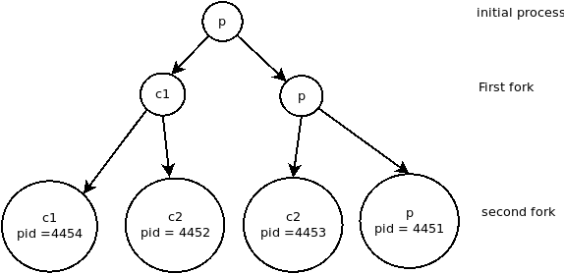

## Question Five

**In the context of our classroom discussions on process state, process operations, and especially process scheduling, describe what you observed and try to explain what is happening to produce the observed results.**

# Process Suspension and Termination

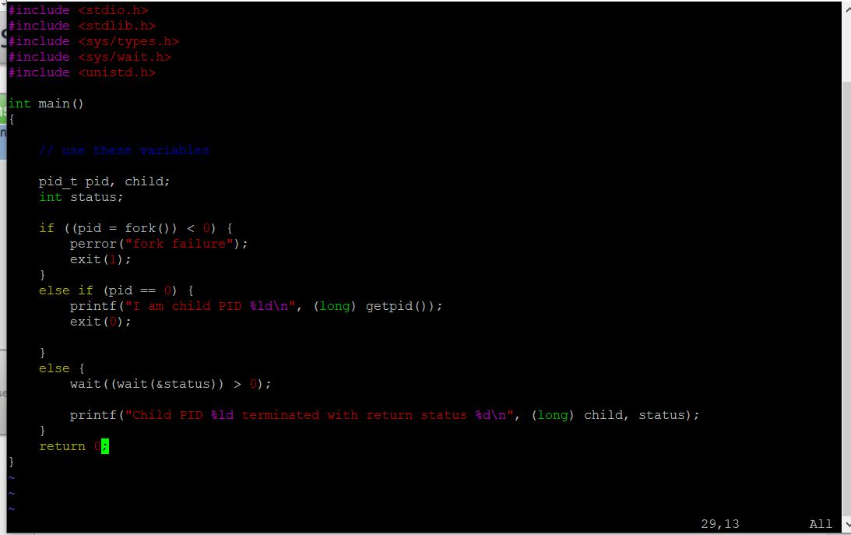SAMPLE PROGRAM 3 REVISED SOURCE CODE:

SAMPLE OUTPUT:

[gigowskm@eos10 lab2]$ ./a.out

I am child PID 22965

Child PID 32766 terminated with return status 0

[gigowskm@eos10 lab2]$

## Question Six

**Provide the exact line of code that you inserted for the wait() system call.**

wait((wait(&status)) > 0);

## Question Seven

**Who prints first, the child or the parent? Why?**

The child, because the next line in the code after the if() conditional that executes fork() is the elseif that addresses the condition if the pid = 0 (pid previously got assigned the value that was returned from fork() ), which would be true within the child process after fork(), but not the parent process (fork() returns twice - the value of 0 to the child process, and the child’s pid to the parent process). Because the condition pid = 0 is not true for the parent process, it passes over this conditional and executes the next one down, but not until after the child process already ran their version of the code.

## Question Eight

**What two values are printed out by the parent in Sample Program 3? (No, not the actual numbers, but what they mean.) In other words, describe the interaction between the exit() function and the wait() system call.**

The values printed by the parent in sample program 3 occur in the print line that runs after the child process has terminated. The first number is the process ID of the child process that finished, which was returned by wait() after the child process exited. The second value is the return status of the child that generated upon it finishing, which was 0 - this means that the child process exited successfully.

# Process Execution

## Question Nine

**When is the second print line ("After the exec") printed? Explain your answer.**

It prints after execvp() executes successfully (at which point it won’t return anything), and the created child process is done with its execution and terminates, the line “After the exec

## Question Ten

**Explain how the second argument passed to execvp() is used?**

The second argument, &argv[1], is a pointer to the starting address of the char array that contains all of the arguments to the program, starting with argv[1]. execvp() passes the array at this starting location to the child process, at which point it then becomes the child process’s argv.

# Programming Assignment (Simple Shell)

## Source Code

#include <stdio.h>

#include <sys/types.h>

#include <unistd.h>

#include <stdlib.h>

#include <sys/wait.h>

#include <sys/times.h>

#include <sys/time.h>

#include <sys/resource.h>

#include "../clib/clib.h"

int main(void) {

char input [50];

pid_t pid;

int status;

struct rusage buf;

char* string[64];

long lastCpuTotal = 0;

long lastSwitchTotal = 0;

do {

memset(input, 0, 50*sizeof(input[0]));

printf("Please enter a command with parameters: \n");

printf(">");

fgets(input, 50, stdin);

printf("\n\n");

strcpy(input,strsegment(input,'\n'));

execParse(input, string);

pid = fork();

if (pid < 0) {

printf("ERROR: Fork operation failed");

exit(1);

} else if (pid) { //parent's code

wait(&status);

getrusage(RUSAGE_CHILDREN, &buf); //Monitors total usage for all children

printf("\n\n\n\n\n");

printf("user cpu time used %ld \n", (buf.ru_utime.tv_usec - lastCpuTotal));

printf("involuntary context switches: %ld\n", buf.ru_nivcsw - lastSwitchTotal);

printf("\n\n\n\n\n");

lastCpuTotal = buf.ru_utime.tv_usec;

lastSwitchTotal = buf.ru_nivcsw;

} else { //everything in here is the child's code

printf("Command entered was" );

if (execvp(*string,string) < 0) {

perror("exec failed");

exit(1);

}

}

}while (strcmp(input,"quit"));

return 0;

}

## Sample Output

